**项目代码介绍：**

* 项目地址：[Delgan/loguru: Python logging made (stupidly) simple](https://github.com/Delgan/loguru)
* 项目star数：23k
* 最近更新时间：13hours之前

---------------------------以上数据记录于2025年11月9日17点02分-丁涛

**核心数据结构：**

1. 属性记录

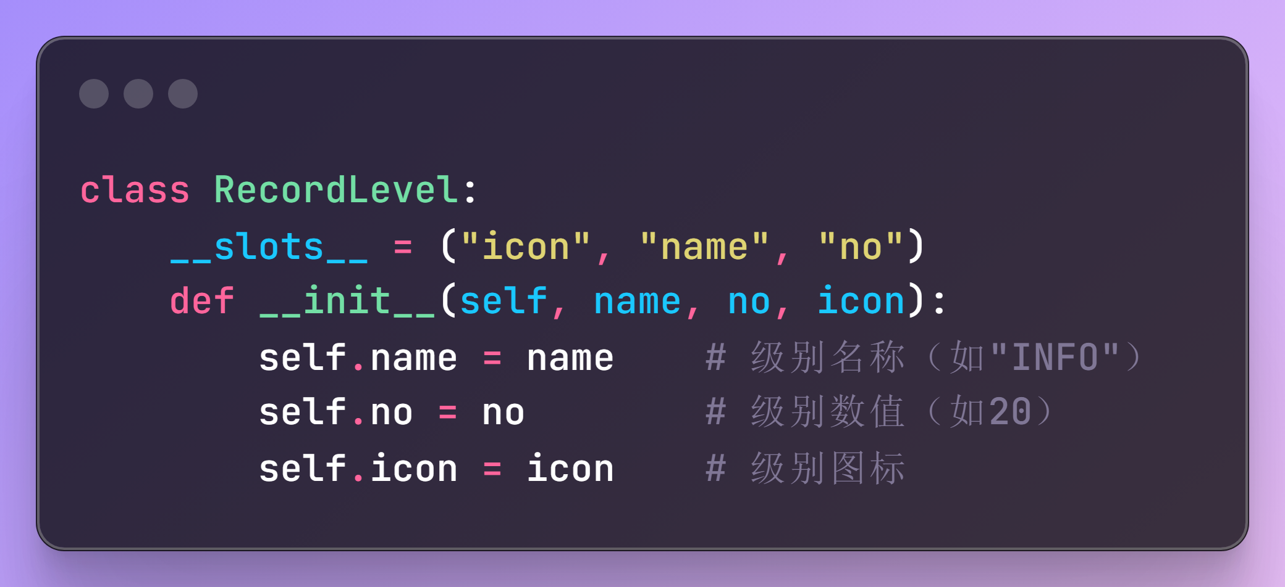

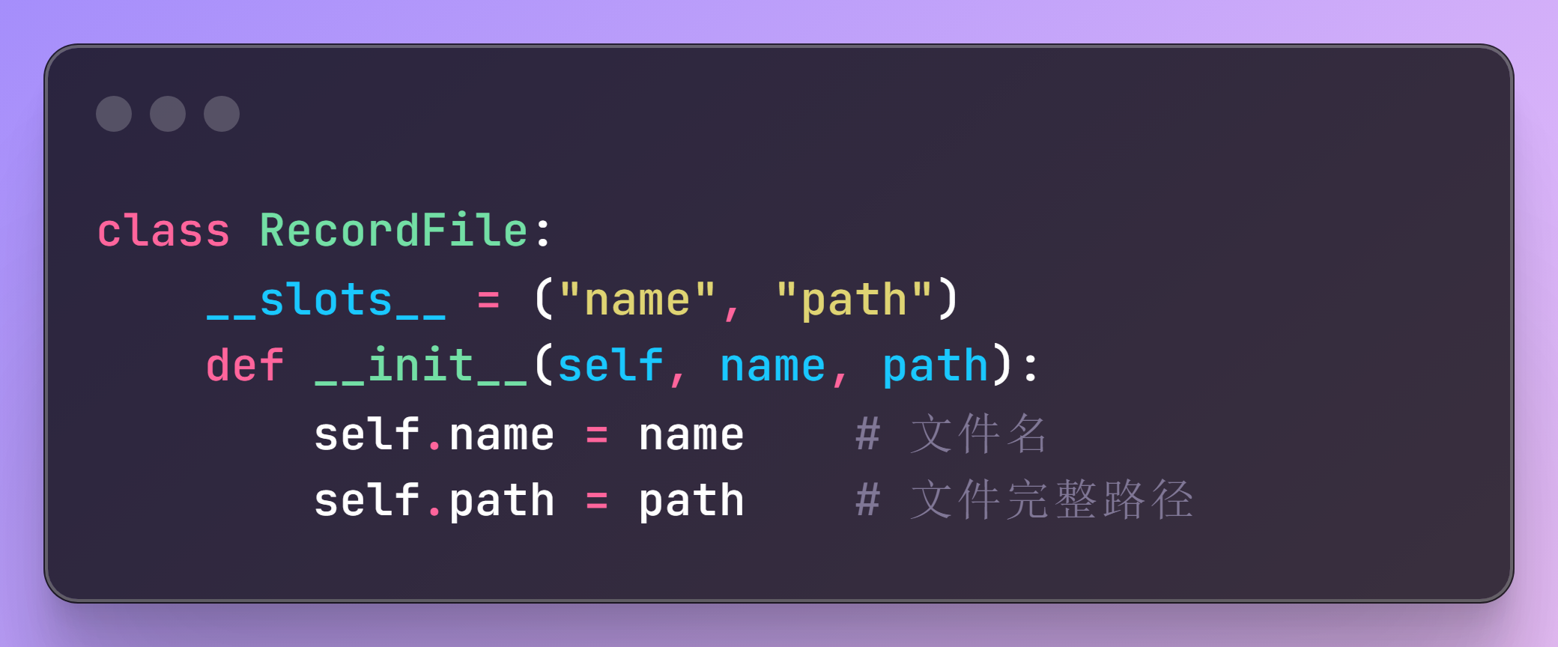

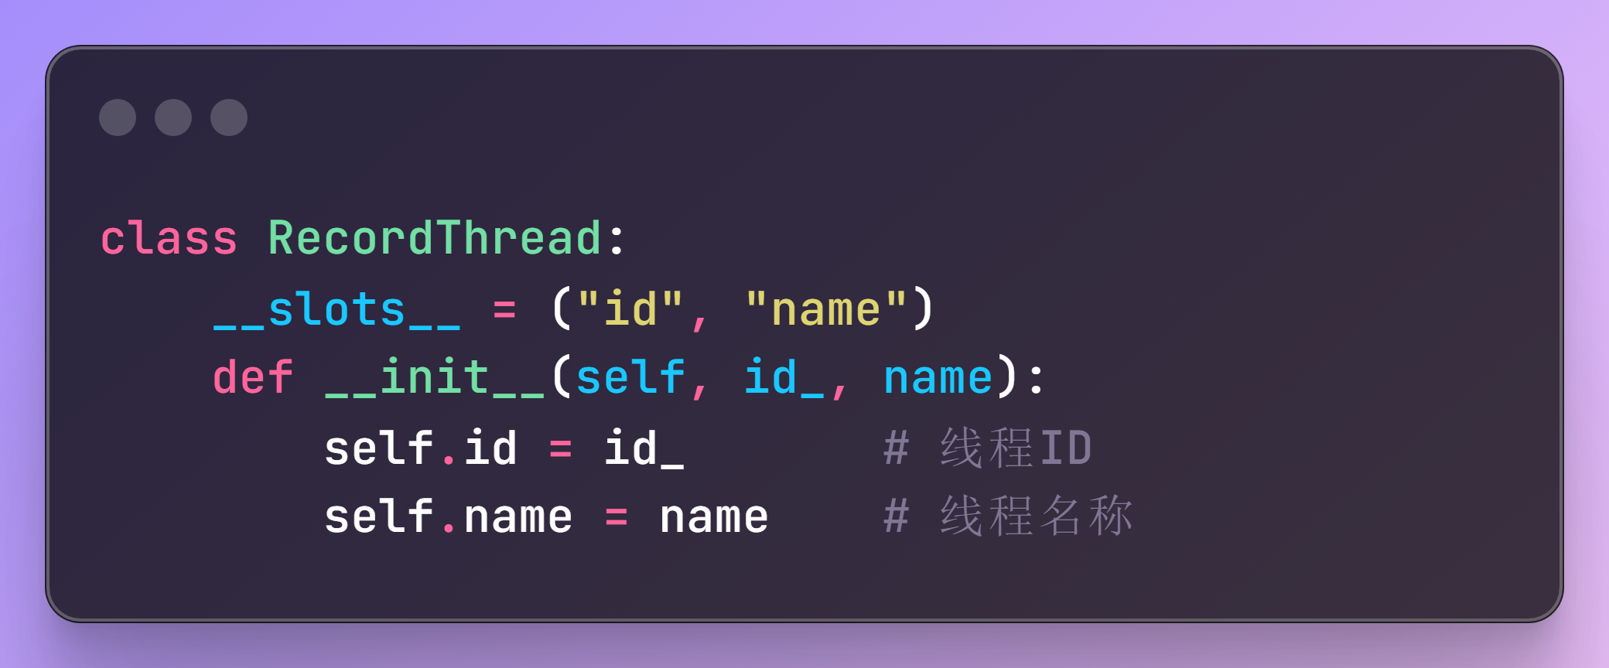

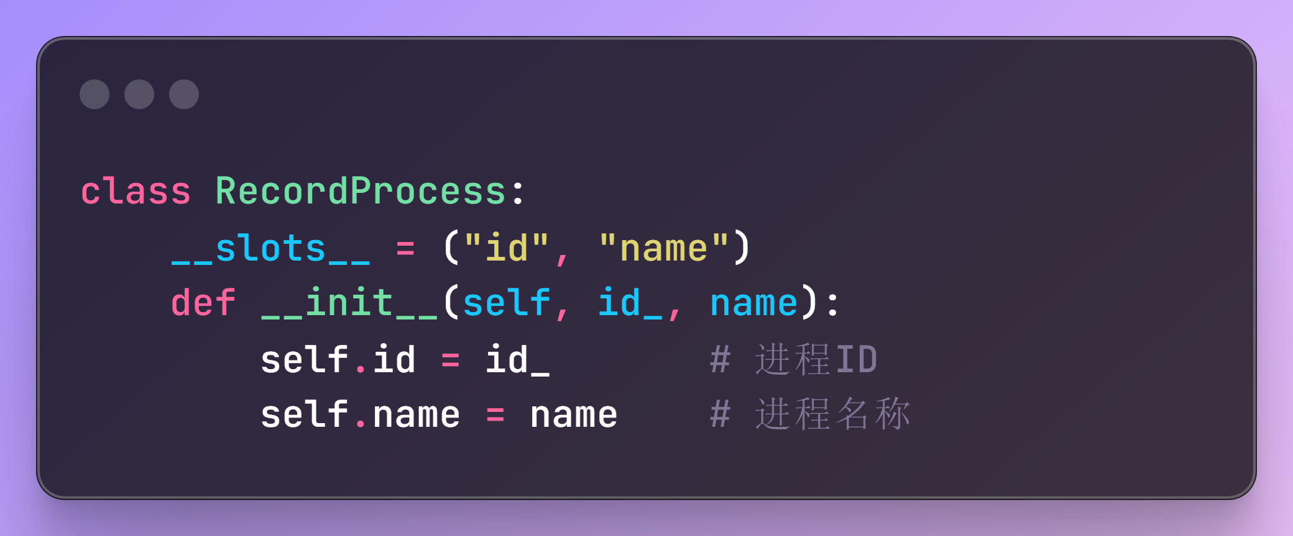

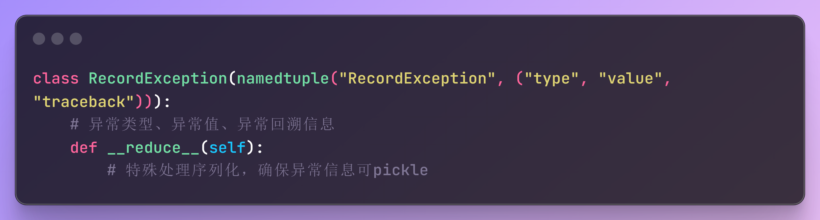

1. 日志记录

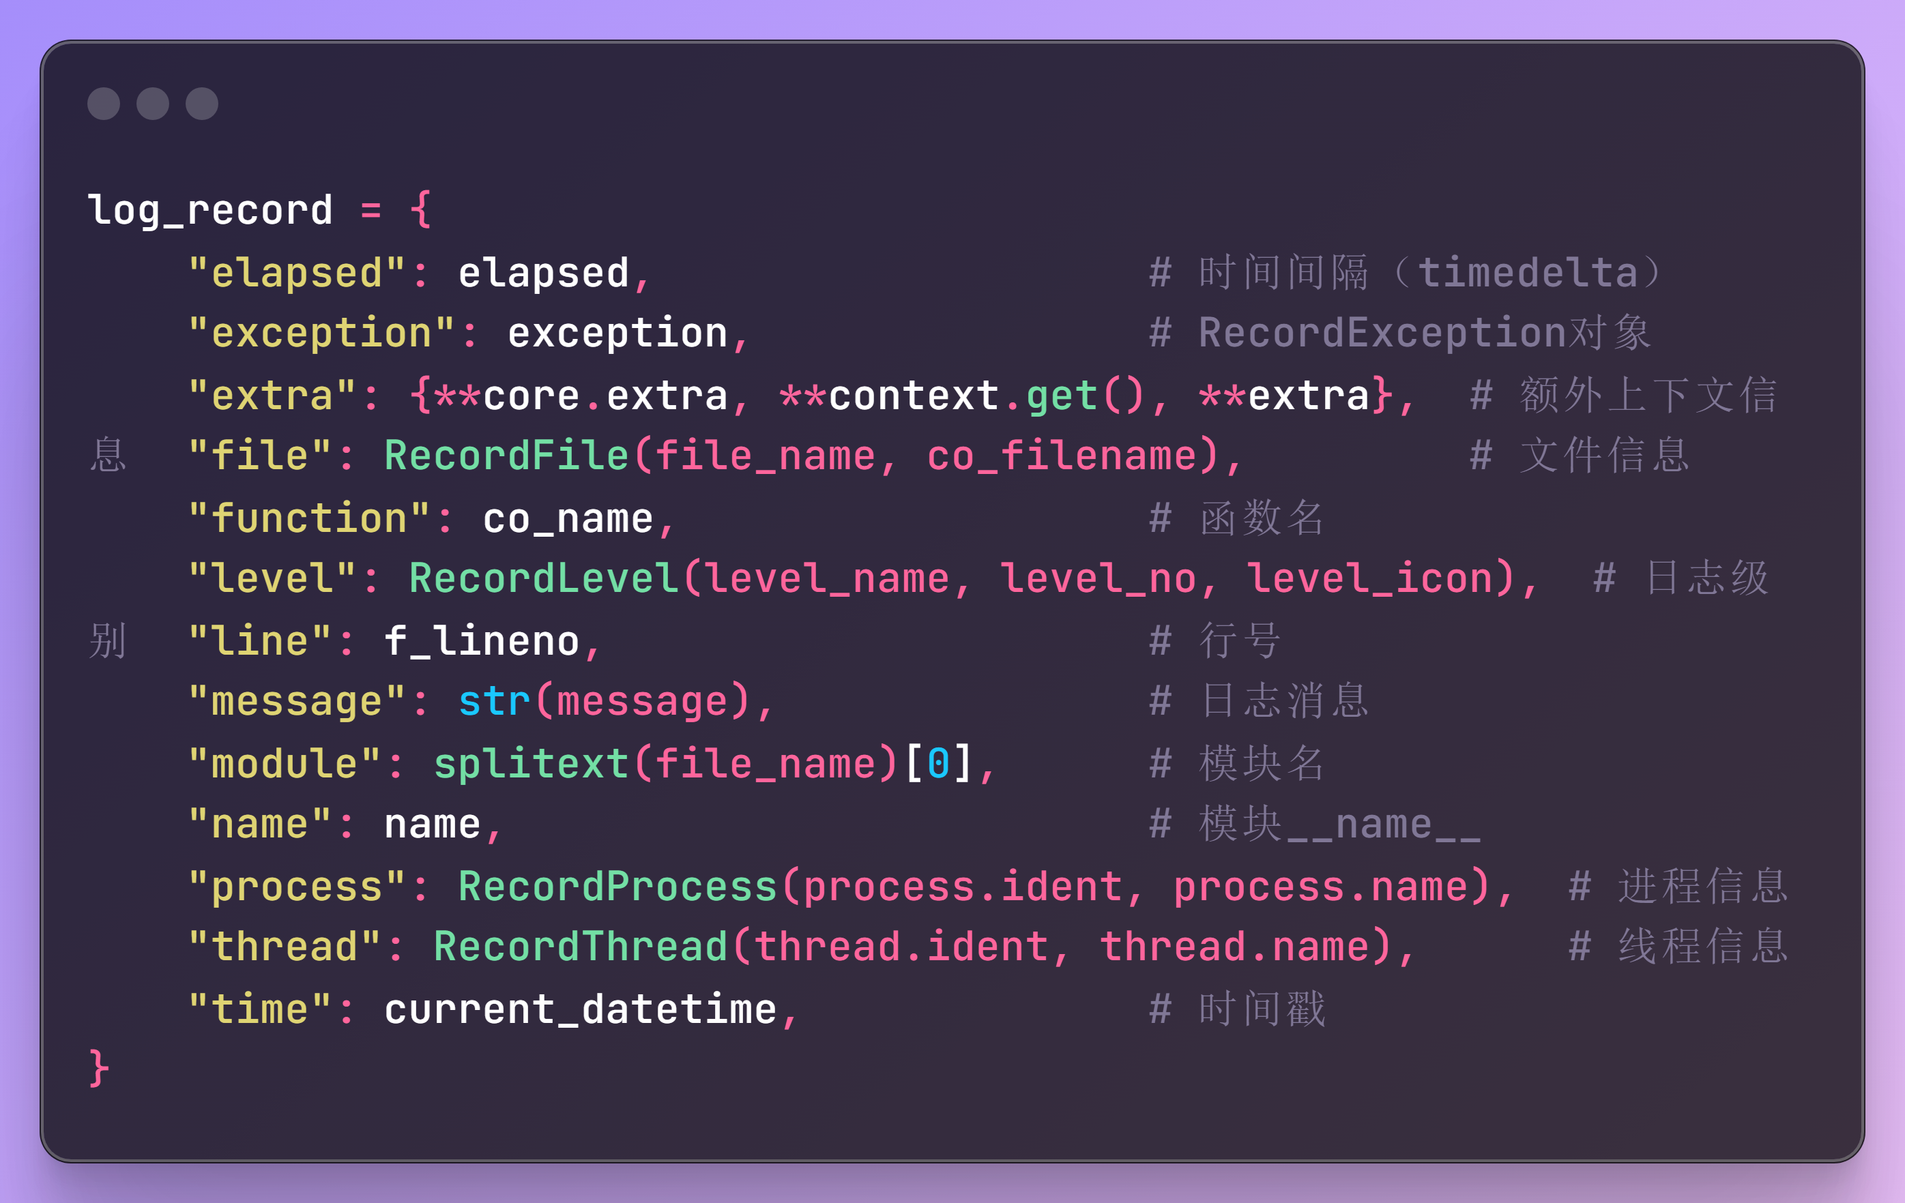

1. 核心配置

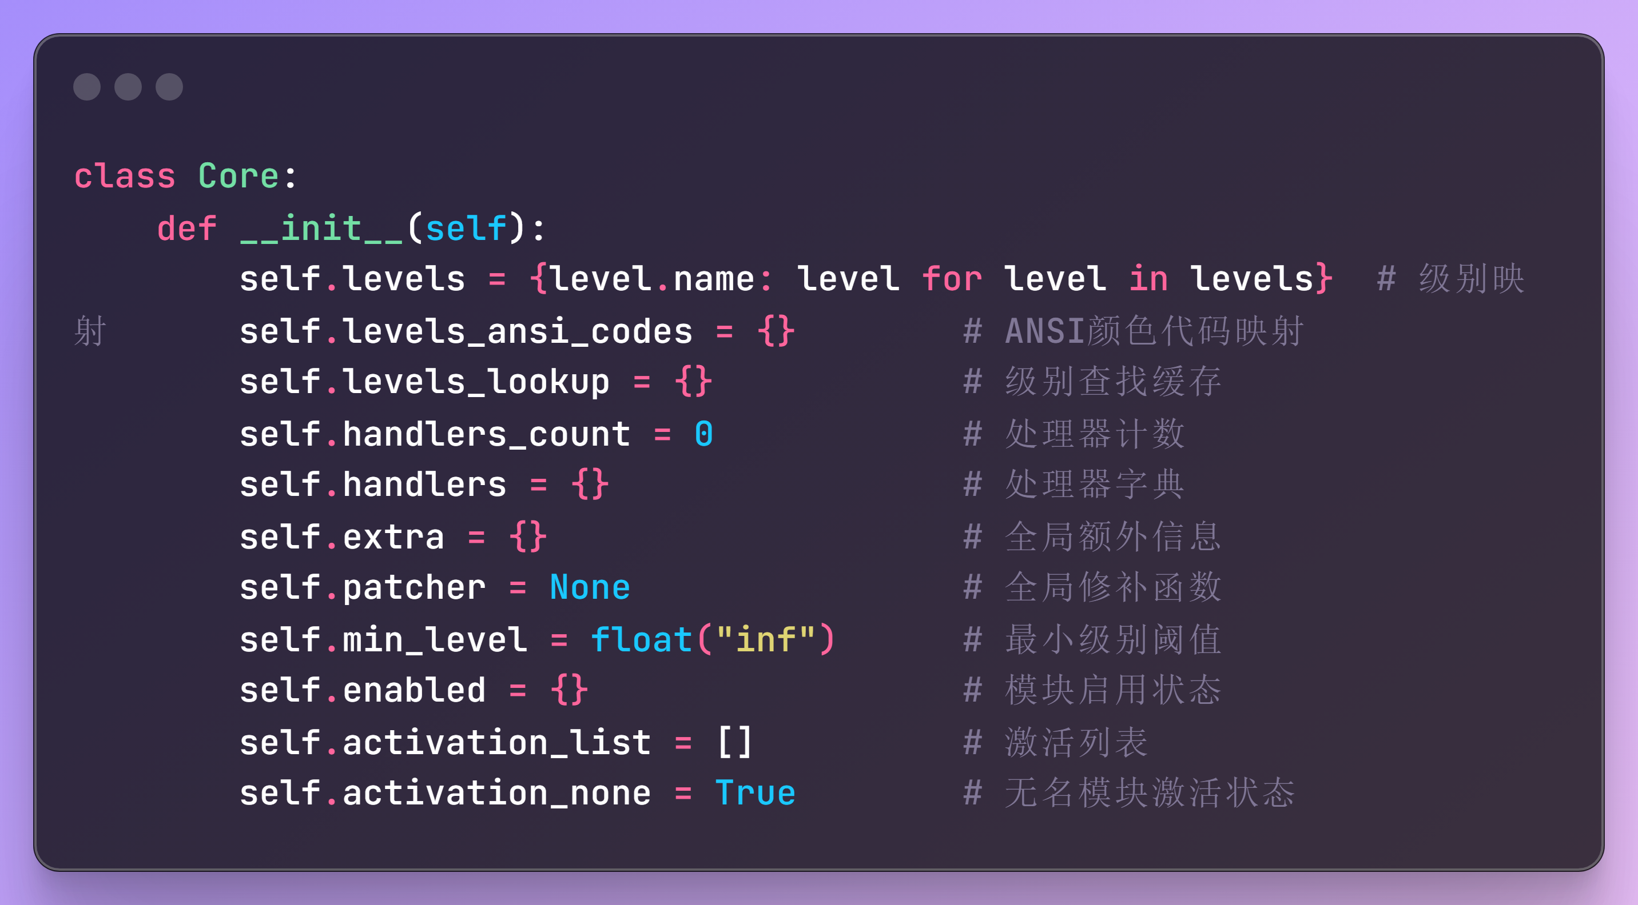

**核心功能流程图：**

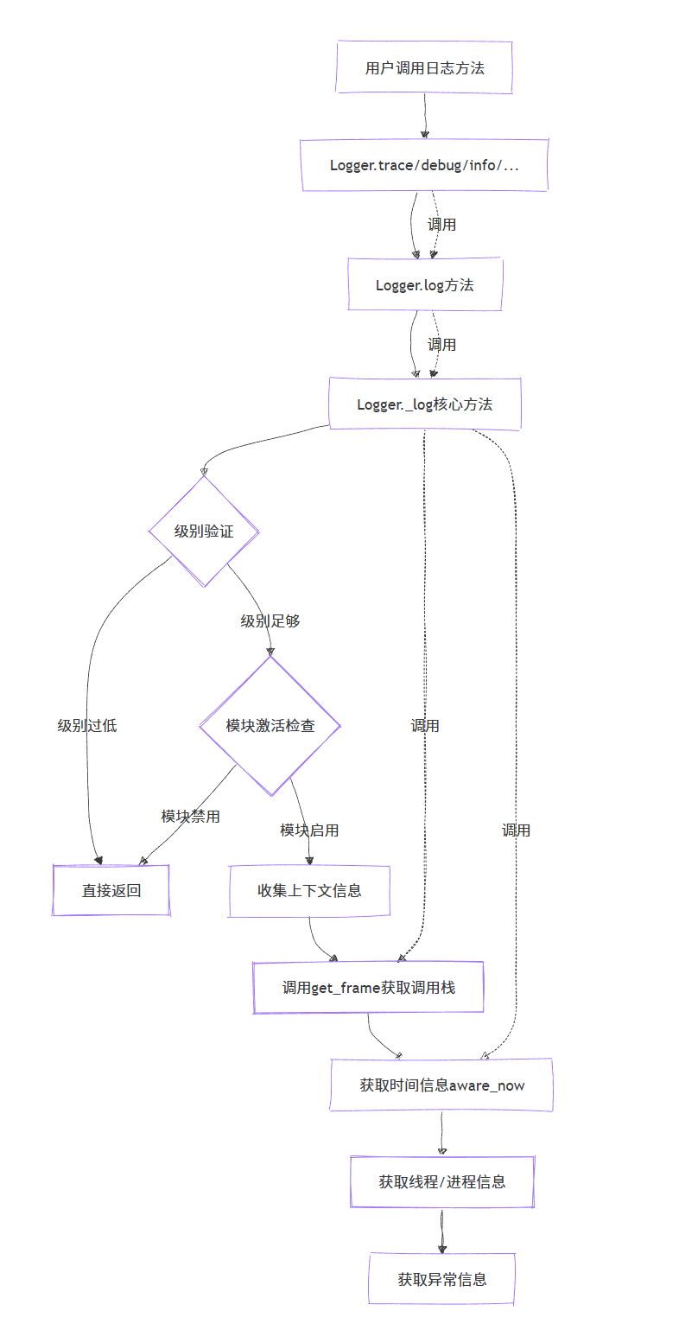

**流程图1**

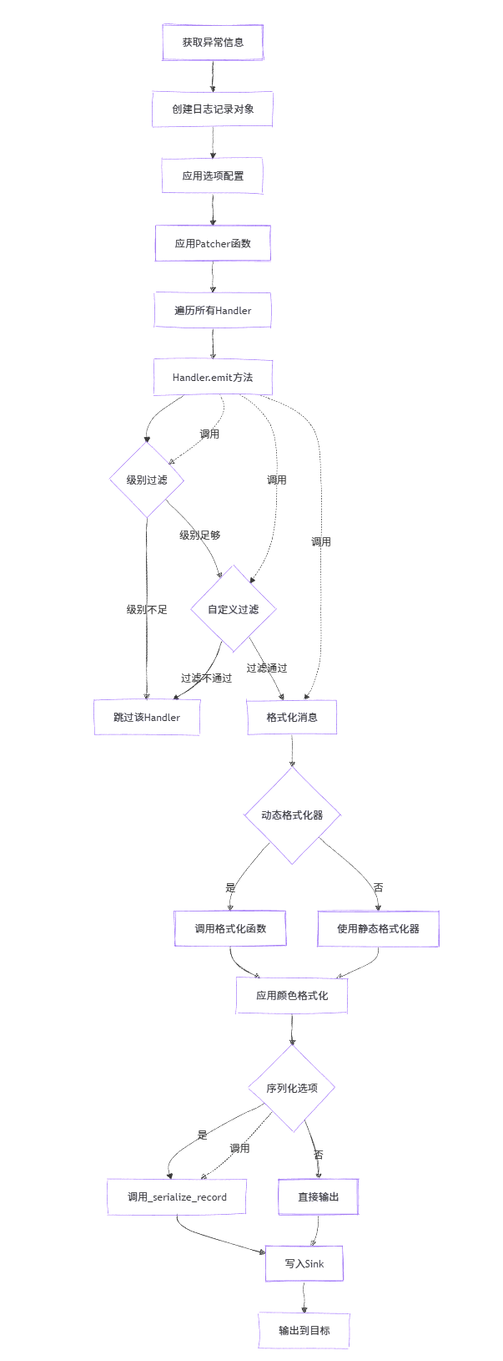

**流程图2**

**设计意图型注释：**1. RecordException类的序列化处理逻辑

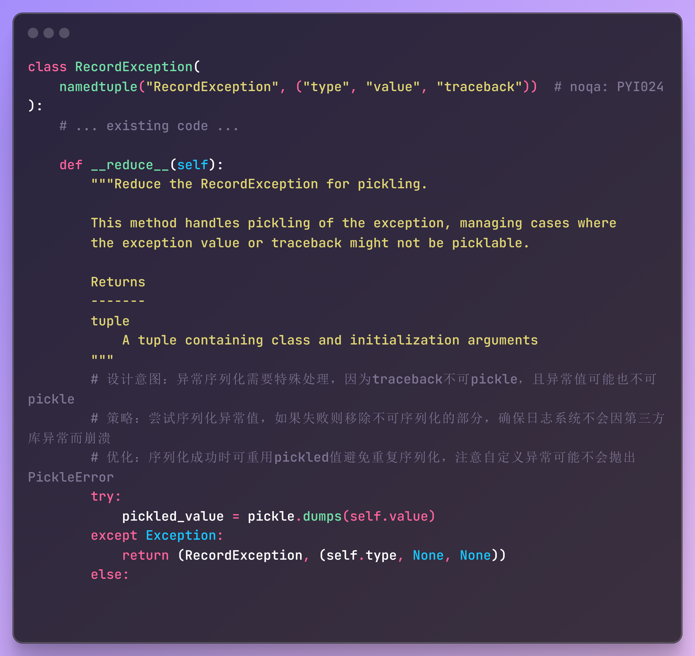

2. Logger类的_log方法中的模块激活检查逻辑

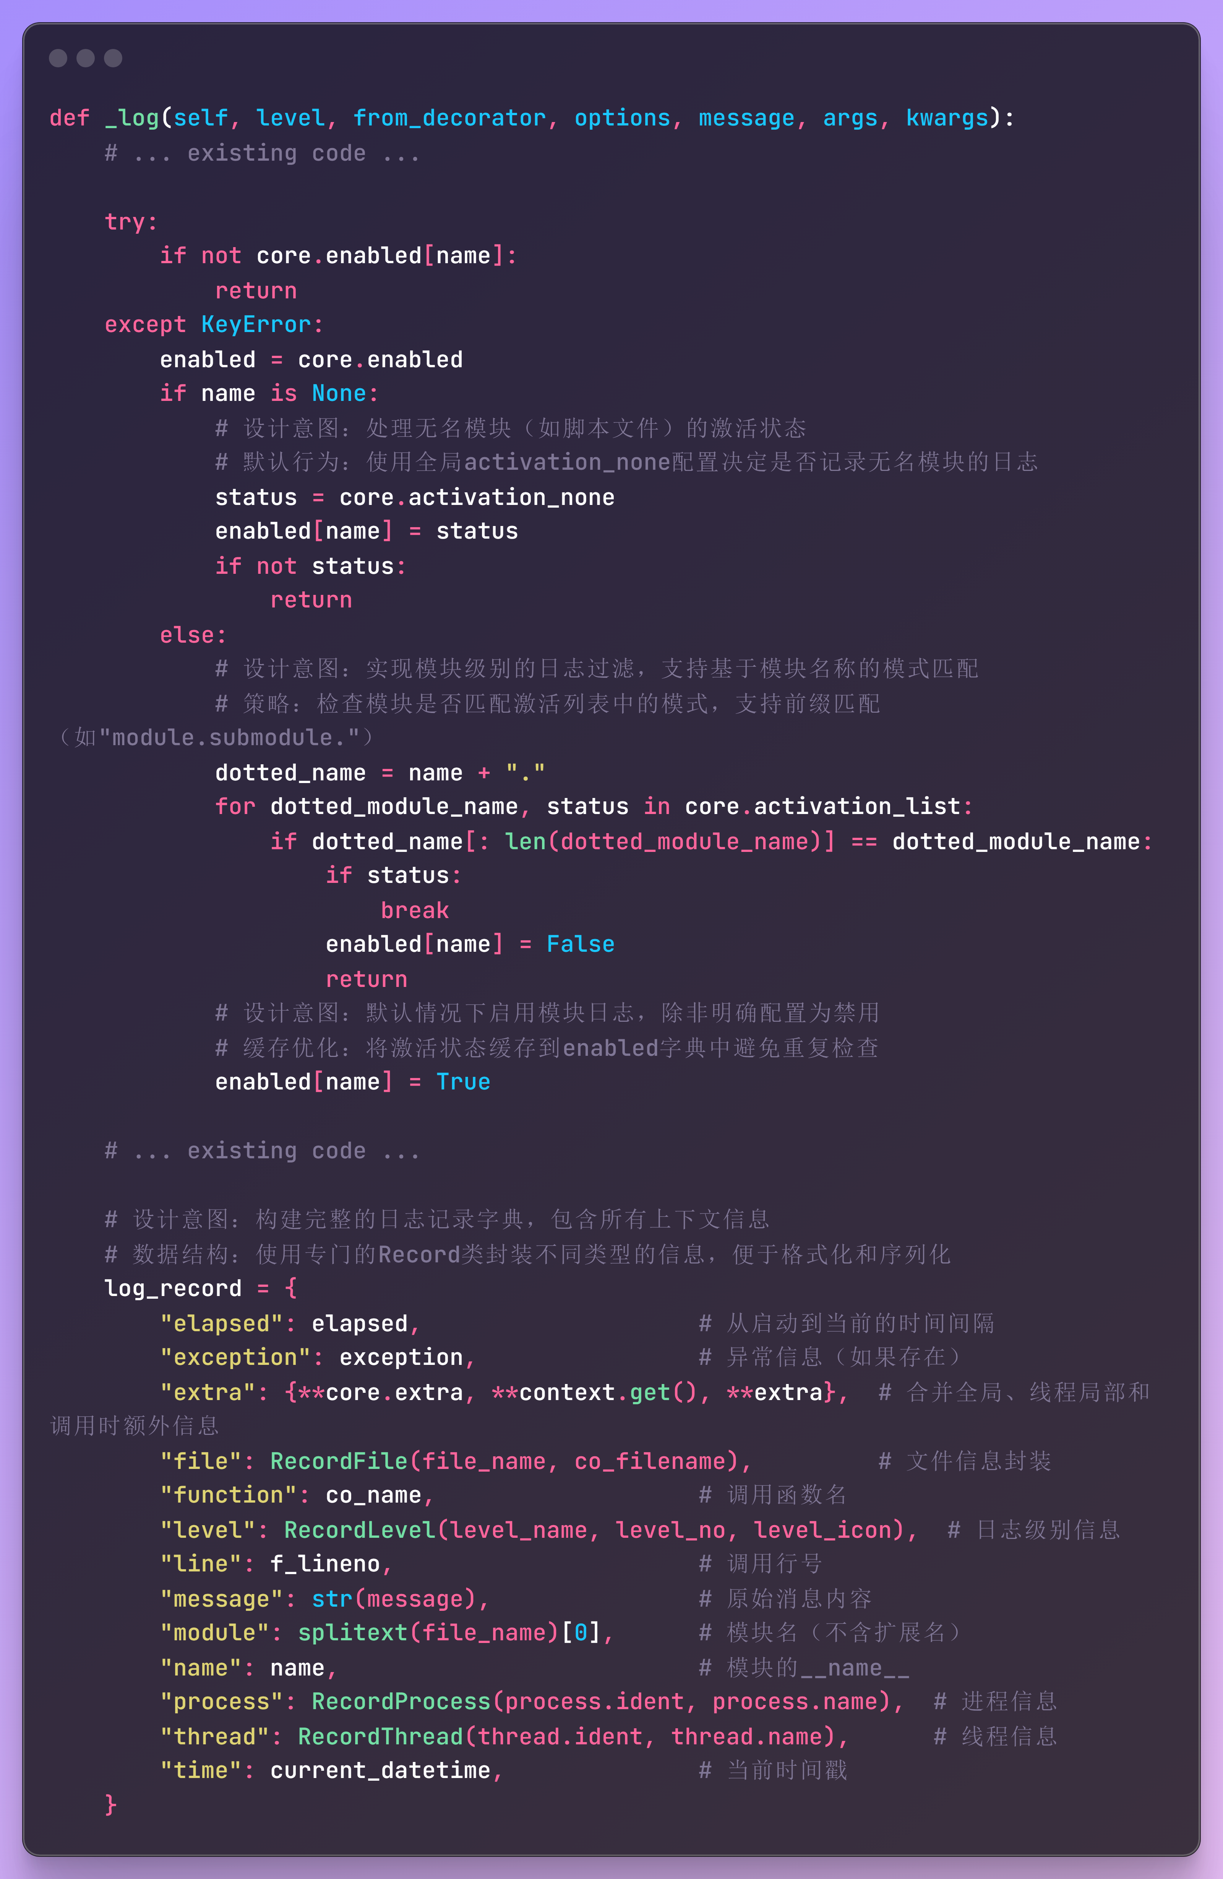

**拓展功能(日志结构化输出增强)**

1. **功能介绍**

基于Loguru现有的结构化日志记录能力，添加对JSON Lines格式的自动支持，同时保持与现有接口的完全兼容。命名为JSONLinesSink类，它可以:

1.基于现有Sink接口：继承自Loguru的Handler机制

2.保持架构兼容：不修改核心Logger/Core类

3.利用现有配置：使用现有的format、filter等选项

4.提供便捷接口：通过新的add_jsonl方法简化使用

1. **实现代码**

"""

JSON Lines sink implementation for Loguru.

This module provides a JSON Lines format sink that can be used with Loguru's

existing add() method or through the convenience method add_jsonl().

"""

import json

from typing import Any, Dict, Optional, TextIO, Union

from ._handler import Handler

from ._logger import Logger

class JSONLinesSink:

"""

A sink that writes log records in JSON Lines format.

This sink automatically serializes log records to JSON format, one record per line,

making it ideal for log aggregation systems and data processing pipelines.

"""

def __init__(self, sink: Union[str, TextIO], **kwargs):

"""

Initialize JSON Lines sink.

Args:

sink: File path or file-like object to write JSON Lines to

**kwargs: Additional arguments passed to the underlying handler

"""

self.sink = sink

self.kwargs = kwargs

def write(self, message: Dict[str, Any]) -> None:

"""

Write a log record as JSON Line.

Args:

message: The log record dictionary to serialize

"""

# Remove the 'message' key and use the actual message content

record = message.copy()

formatted_message = record.pop('formatted_message', record.get('message', ''))

# Create JSON structure with message as the main content

json_record = {

'timestamp': record.get('time', {}).get('timestamp', None),

'level': record.get('level', {}).get('name', 'INFO'),

'message': formatted_message,

'module': record.get('file', {}).get('name', ''),

'function': record.get('function', ''),

'line': record.get('line', 0),

'process': record.get('process', {}).get('name', ''),

'thread': record.get('thread', {}).get('name', ''),

'extra': record.get('extra', {})

}

# Add exception information if present

if record.get('exception'):

json_record['exception'] = {

'type': record['exception'].get('type', ''),

'message': record['exception'].get('message', ''),

'traceback': record['exception'].get('traceback', '')

}

# Write as JSON Line

if hasattr(self.sink, 'write'):

self.sink.write(json.dumps(json_record) + '\n')

self.sink.flush()

else:

with open(self.sink, 'a', encoding='utf-8') as f:

f.write(json.dumps(json_record) + '\n')

def add_jsonl(

self: Logger,

sink: Union[str, TextIO],

*,

level: Optional[Union[str, int]] = None,

format: Optional[str] = None,

filter: Optional[Union[str, dict]] = None,

colorize: Optional[bool] = None,

serialize: bool = False,

backtrace: bool = True,

diagnose: bool = True,

enqueue: bool = False,

catch: bool = True,

**kwargs

) -> int:

"""

Add a sink that outputs logs in JSON Lines format.

This is a convenience method that creates a JSON Lines sink with appropriate

formatting for JSON output.

Args:

sink: File path or file-like object for JSON Lines output

level: Minimum logging level

format: Log format string (optional, uses JSON-friendly format by default)

filter: Log filter configuration

colorize: Whether to colorize output (False for JSON Lines)

serialize: Whether to serialize the message (True for JSON Lines)

backtrace: Whether to format exception backtraces

diagnose: Whether to display diagnostic information

enqueue: Whether to enqueue messages for thread safety

catch: Whether to catch errors in the sink

**kwargs: Additional arguments for the sink

Returns:

The handler ID that can be used with remove()

Example:

>>> logger.add_jsonl("logs.jsonl")

>>> logger.info("User login", user_id=123, action="login")

# Output in logs.jsonl: {"timestamp": "...", "level": "INFO", "message": "User login", "user_id": 123, "action": "login"}

"""

if format is None:

format = "{time:YYYY-MM-DD HH:mm:ss.SSS} | {level: <8} | {name}:{function}:{line} - {message}"

# Create JSON Lines sink handler

jsonl_sink = JSONLinesSink(sink, **kwargs)

# Add to logger with JSON-friendly configuration

return self.add(

jsonl_sink.write,

level=level,

format=format,

filter=filter,

colorize=False, # JSON should not be colorized

serialize=True, # Ensure proper serialization for JSON

backtrace=backtrace,

diagnose=diagnose,

enqueue=enqueue,

catch=catch

)

# Add the method to Logger class

Logger.add_jsonl = add_jsonl

在初始化函数中添加对JSONLinssSink类的引入（代码省略）

1. **使用实例**

from loguru import logger

# 基本用法 - 添加到JSON Lines文件

logger.add_jsonl("application.log.jsonl")

# 带级别过滤的用法

logger.add_jsonl("error.log.jsonl", level="ERROR")

# 使用示例

logger.info("User login successful", user_id=123, ip="192.168.1.1")

logger.error("Database connection failed", db_host="localhost", error="Connection timeout")

# 输出的JSON Lines格式：

# {"timestamp": "2024-01-15 10:30:00.123", "level": "INFO", "message": "User login successful", "user_id": 123, "ip": "192.168.1.1"}

# {"timestamp": "2024-01-15 10:31:00.456", "level": "ERROR", "message": "Database connection failed", "db_host": "localhost", "error": "Connection timeout"}